PROBLEM STATEMENT
The pet industry is huge and ever growing. Dogs are the most preferred pets. Currently, the only way to find the breed of a dog, is to inquire about it from either the owner of the dog or the professionals in the industry. This can be a time consuming and confusing experience for a prospective dog owner. Finding the breed of a dog should be as easy as snapping a picture. However, currently there is a lack of an application that addresses this market need. In this paper, we have built an app for the android platform that uses Convolutional Neural Networks (CNN) and Transfer learning to identify the breed of a dog by simply snapping a picture of it
OBJECTIVE
Dogs are the most preferred among pets. Potential customers who are looking to buy a dog may do their research by scouting dogs owned by other people. It may not always be possible to approach the owner and inquire about the breed the dog belongs to. Additionally, it is possible that the owners themselves may be unaware of the breed of their dog. Nowadays, convolutional neural networks (CNN) [1] are popular in different topics of deep learning: image recognition [1], detection [2], speech recognition [3], data generation [4], etc. Several traditional image recognition methods are known: Scale-Invariant Feature Transform (SIFT) [5], Histogram of Oriented Gradients (HoG) [6], attribute classification with classifiers: Support Vector Machine (SVM), Softmax and Cross Entropy loss. However, CNNs have also gained significant traction in this field in recent years, mostly due to general reoccurring architectures being viable for solving many different problems
ABSTRACT
Deep learning and computer vision algorithms will be applied to find the breed of the dog from an image. The goal is to have the user submit an image of a dog, and the model will choose one of the 120 breeds stated in the dataset to determine the dog’s breed. The proposed work uses various deep learning algorithms like Xception, VGG19, NASNetMobile, EfficientNetV2M, ResNet152V2, Hybrid of Inception &Xception, and Hybrid of EfficientNetV2M, NASNetMobile, Inception &Xception to predict dog breeds. ResNet101, ResNet50, InceptionResNetV2, and Inception-v3 on the Stanford Dogs Standard Datasetswere used in the existing system. The proposed models are considered a hybrid of Inception-v3 &Xception and a hybrid of EfficientNetV2M, NASNetMobile, Inception & Xception. This hybrid model outperforms single models like Xception, VGG19, InceptionV3, ResNet50, and ResNet101.The authors used a transfer learning algorithm with data augmentation to increase their accuracy and achieved a validation accuracy score of 71.63% for ResNet101, 63.78% for ResNet50, 40.72% for InceptionResNetV2, and 34.84% for InceptionV3. This paper compares the proposed algorithms with existing ones like ResNet101, ResNet50, InceptionResNetV2, and InceptionV3. In the existing system, ResNet101 gave the highest accuracy of 71.63%. The proposed algorithms give a validation accuracy score of 91.9% for Xception,55% for VGG19, 83.47% for NASNetMobile, 89.05% for EfficientNetV2M, 87.38% for ResNet152V2, 92.4% for Hybrid of Inception-v3 &Xception, and 89.00% for Hybrid of EfficientNetV2M, NASNetMobile, Inception &Xception. Among these algorithms, the Hybrid of Inception-v3 &Xception gives the highest accuracy of 92.4%.

CHAPTER-1
INTRODUCTION
Nowadays, there is an increasing demand and usage of image classification and verification techniques; the most significant technique used for image data classification is a deep learning model known as Convolutional Neural Networks (CNN). Deep learning is increasingly becoming a crucial tool in artificial intelligence applications. Optical Character Recognition and facial recognition are two examples of computer vision applications. These areas offer impressive results, fueling increasing interest in deep learning. Classifying images is a field in which deep learning excels. CNNis the most popular deep-learning method for classifying images. The proposed work is to investigate a variety of Convolutional Neural Network models for classification. The created algorithm might be used in a mobile or online application. Transfer training, which helps us produce effective outcomes, was used to create the CNN that categorizes dog breeds. Convolutional Neural Networks (CNNs) are made up of neurons with adjustable biases and weights. The dot product is computed by each neuron using input data. Convolution Neural Network architectures differ from other neural networks in that itrelies on actual images as inputs, unlike other neural network types. This enables the inclusion of particular components in the design. CNN lower the number of observable variables that characterize a network. Single-layer neurons act independently from prior layers. A convolutional neural network architecture from the Inception family called Inception-v3 employs an additional classifier, factorized 7 × 7 convolutions, and label smoothing to carry label information further down the network. Deep-separable convolution layers make up the complete architecture of the CNN called Xception. A type of Convolution Neural Network called NASNetwas found through research into neuronal design. Normal cells and decreasing cells serve as the foundation. EfficientNet is a CNN architecture; all depth, width, and resolution factors are scaled using a compound coefficient method. The Efficient Net scaling technique, in contrast to conventional practice, uniformly adjusts network width, depth, and resolution using a collection of fixed scaling coefficients. Residual Networks, or ResNets, rather than learning nonreferenced functions, learn residual functions about layer inputs. The residual nets enable those layers to match a residual map instead, assuming that each stacked layer exactly matches a desired underlying map. ResNets stack residual blocks together to build networks, such as ResNet-50, which has 50 layers. A deep convolutional neural network is generally challenging to train from the start. Because size and depth data set relevant to the neural network are rare, using transfer learning as a feature extractor is optimal. A model was already trained on a large data collection. Transfer learning is a crucial component of deep convolutional neural networks that offers solutions to these issues. In computer vision, transfer learning is defined as using a pre-trained model. A pre-trained model must have been trained on a sizable benchmark dataset to handle an issue similar to ours. The magnitude of the new dataset and how closely it resembles the existing dataset play a significant role in determining transfer learning. So, before using transfer learning, a few circumstances shall be considered. The efficacy of the CNN is reduced by overfitting when the new dataset is smaller but contains the same data as the old dataset. If the new dataset is large and has content comparable to the old data, the model can be refined using the entire network.

1.2. LITERATURE REVIEW
- In this research [1], to categorize and identify pet dogs’ faces, the researchers offered an improved Yolov3 model. Eight distinct breeds of pet dogs were used to construct the data set for this study. The data set was split into two categories: training and testing, with the training set being used to train the established model. Using more widespread pet dogs as samples, it was suggested by the authors a yolov3-based pet dog categorization model. Instead of using the pet dog’s general characteristics, the model chose the face of the pet dog and marked the dog category by detecting facial features, similar to face detection. The trials’ findings demonstrated that this approach was capable of rapidly and correctly locating the position of a pet dog’s face, and it resolved the issue of pet dog detection and categorization.
- In this paper [2], the authors studied how animal identification in veterinary practice was managed through machine learning. Electronic animal health records included digital image graphs using image processing and recognition technology to identify animals. The authors studied how combining ‘‘soft’’ biometrics, such as breed and facial biometrics, could improve dog identification. The researchers applied transfer learning from GoogLeNet to propose Breed- Net for breed classification and subsequently to propose DogNet for identifying individual dogs within the classified breeds.
- In this article [3], by determining a dog’s breed in a given image, this work aimed to solve the problem of fine-grain and multi-class image recognition. One of the sophisticated deep learning approaches used in the research system was convolutional neural networks. Two distinct networks were constructed and assessed using the Stanford Dogs dataset. Convolutive neural networks’ application and evaluation were demonstrated using a software system. It had a central server and a mobile client with resources and tools for online and offline neural network analysis. Two distinct convolutional neural network architectures were presented: the Inception- ResNet-v2 deep architecture and the NASNet-A mobile architecture. Deep Inception-ResNet-v2 model outperformed even the smaller, mobile-friendly CNN, with results that were still encouraging.
- This study [4] provided two models for categorizing dogs into different breeds. Due to the increasing difficulty of classifying dogs and the fact that these classifications were based on deep learning, forming the two models that provide different levels of accuracy at both ends requires a fully defined data set. Since every model was periodically subjected to predictions, the researchers encountered numerous functioning levels during the investigation that weren’t considered in earlier research. The essential concept of transfer learning, which dealt with the data augmentation technique and its capacity to increase the size of the data set, is also built upon by their approach. Afterward, accuracy levels were matched or compared with both models to establish a comparison for both models. A detailed procedure was also used to classify the data. The comparison between Inception V3 and VGG16 was offered in the publication. Observations showed that Inception V3 offered an accuracy of 85, whereas VGG16 provided a much lower accuracy of 69 than the Inception V3 model.
- In this article [5], deep learning made it possible to train algorithms (models) that could categorize and forecast data based on the knowledge that was extracted (learned) from the raw data. Convolutional Neural Networks were one method that was commonly employed for image categorization and detection. In this research, the authors discussed dog breed/type identification after providing a CNN-based method for dog detection in potentially complex images. The findings had a 64% accuracy rate for 120 additional, less common dog varieties and a breed classification accuracy of about 85% for a group of 50 dog breeds. A big data processing infrastructure using a variety of GPUs and an Ios application supporting image classification techniques were used. To enhance the integrity of the data, several preparation methods were employed.
- In this study [6], there were many different species and organisms in the world today. This highlights how important it was to classify different tangible objects. Determining the similarities between distinct classes also became extremely important in light of the continuing genetics and evolution study being conducted by scientists worldwide. The experiment that provided the basis for this essay involved classifying different canine breeds using a CNN (Convolutional Neural Network). This algorithm will identify an estimated breed if a canine image is found. The type of dog that most closely resembled a human, if one was given, was identified. The authors created a pipeline to handle photos from the actual world. The dog breed classifier did an excellent job, with extremely good accuracy.
- In this article [7], the researchers used cutting-edge models on Imagenet data sets. To extract the feature from the data set used to identify dog breeds, the pre-trained model and learned weights were used. After that, data augmentation and fine-tuning were used to improve the performance of their test’s breed categorization accuracy. The performance of the proposed methods was compared with the GoogleNet, DenseNet-169, DenseNet-121, and ResNet-50 models from the most current Image-Net dataset. Their respective test accuracies were 82.08%, 84.01%, 85.37%, and 89.66%, demonstrating the proposed method’s superior performance to earlier efforts on Stanford dog breed datasets. Stanford dog breed datasets presented a modified approach to cutting-edge networks like ResNet, DenseNet, and GoogleNet. Due to the limited training datasets, data augmentation and fine-tuning were conductedto improve the test set experiments’ accuracy.
- In this paper [8], the character of an animal like a dog has changed significantly from earlier generations due to extensive breeding or cross-breeding. Contrary to eye-only recognition, image processing for breed analysis allowed the most accurate prediction of the exact outcome or results. Breed analysis and identification were made using the ADA boosting methodology. By combining numerous weak classifiers, ADA Boosting produced a robust classifier. The authors employed image processing classification to distinguish between the many dog breeds. It accurately predicted the dominant breed or breeds present in the canine. The proper breed(s) were identified using image processing algorithms for breed classification because the dogs might be cross-breed ancestors. It would be necessary for straightforward breed-based dog categorization, and it could demonstrate how unreliable or trivial breed identification by the naked eye is. The authors could study and perform animal recognition using image processing, including sheep, cattle, and others. VGG Net was an extensive collection of pre-defined CNN demonstrating its ability to utilize/prepare pictures on most subjects accurately.
- This article [9] used Convolutional Neural Networks specifically for dog breed detection. Despite being an effective method, convolutional neural network classification still has a few flaws. For training, Convolutional Neural Networks require many images and much time to get better classification accuracy. The authors employed transfer learning to get around this lengthy period. Learning in computer vision refers to training the CNN using a pre-trained model. A pretrained model was trained to solve a classification problem comparable to the onethe researchers had using transfer learning. In this research, the authors trained over 1400 photos encompassing 120 dog breeds using various pre-trained models, including VGG16, Xception, and InceptionV3. Then the bottleneck features were used in these pre-trained models to identify bottlenecks. Last, Logistic Regression, a multiclass classifier, was used to determine the dog breed from the photos. It achieved 91%, 94%, and 95% validation accuracy for the various pre-trained models VGG16, Xception, and InceptionV3.The dog was one of the most common domesticated animals. Having so many dogs led to several issues, including population control, decreased rabies outbreaks, vaccination control, and formal ownership. Currently, there are about 180 distinct canine breeds. Each canine breed had distinctive characteristics and health problems. To deliver the appropriate therapies and training, it was essential to identify individuals and their breeds. The article illustrates the classification approaches for dog breed classification using two image processing techniques.
  - Two instances of conventional techniques were the Histogram of Oriented Gradient and the Local Binary Pattern (LBP).
  - The deep learning-based strategy utilizing transfer learning and Convolutional Neural Networks (CNN).
The outcome demonstrated that their CNN model that had been trained better performed when classifying dog breeds. Compared to 79.25% accuracy when using the HOG descriptor, it achieved 96.75% accuracy [10]. With improved techniques, image classification made significant progress and improved accuracy. However, there was a ton of room for improvement regarding fine-grained classification. The different animals could all be recognized from the image, but it was more challenging to determine the breed of each animal. This essay aims to advance the classification of animal breeds. Several pre-trained deep learning models were trained and tested using the standard Stanford dog breed dataset. The pre-train network was tweaked, and the results were compared. The training process data recorded while tabular forms. Comparative analysis was performed using each network that has recorded data, and the results are displayed. DenseNet201 reported a testing accuracy of 87.15%, GoogleNet reported a testing accuracy of 81.53%, AlexNet reported a testing accuracy of 84.35%, and ResNet50 reported a testing accuracy of 90.12%. The final three layers of each network were modified to produce these results. The study could be expanded by considering more models and experimenting with layer modifications [11].Classifying images of dogs by breed was difficult, making it a problematic picture classification task. In this study [12], a Convolutional Neural Network (CNN) and transfer learning model-based Android application was created that analyses images to identify a dog’s breed. The Android application allows users to capture or upload dog photos. The features required for testing were then extracted after the picture underwent pre-processing. Based on transfer learning and CNN, dog breed predictions were made. The model was taught using Stanford’s standard dog dataset, and it had a 94% accuracy rate when tested against actual data. The intended work had been effectively designed, implemented, and tested. The authors had created a simple Android application that allowed users to submit or choose an image to determine a dog’s breed. There was a very short waiting time because it worked without an internet link and gave the answer right away. In this study it was shown how to build a dog breed recognition model and deploy it on an Android device using pre-trained models. The application’s size could be reduced in the future with the help of enhancements.

CHAPTER-2
SYSTEM ANALYSIS
1. EXISTING SYSTEM
The existing dog breed classification systems primarily rely on traditional machine learning or CNN-based deep learning models. These approaches have shown moderate success but face several limitations due to their inability to capture both local and global image features effectively.
Key Features of the Existing System
1.1 Machine Learning-Based Approaches
Early methods used handcrafted feature extraction techniques such as:
- Histogram of Oriented Gradients (HOG)
- Local Binary Patterns (LBP)
- Scale-Invariant Feature Transform (SIFT)
These extracted features were then fed into classifiers like Support Vector Machines (SVMs), k-Nearest Neighbors (k-NN), and Random Forests for breed classification.
Limitations:
- Feature extraction was manual and time-consuming.
- Struggled with background clutter, lighting variations, and occlusions.
- Low accuracy on large-scale datasets with fine-grained breed differences.
1.2 CNN-Based Deep Learning Models
With the rise of deep learning, researchers shifted to Convolutional Neural Networks (CNNs) for automatic feature extraction and classification. The most commonly used models include:
- VGG16/VGG19
- ResNet50, ResNet101
- InceptionV3, InceptionResNetV2
- EfficientNetV2
Limitations:
- CNNs only focus on local spatial features, ignoring global image context.
- Some breeds exhibit high visual similarity (e.g., Huskies vs. Malamutes), leading to misclassification.
- Pose variations and background differences significantly impact classification accuracy.
Key Study Findings:
- ResNet101 achieved 71.63% accuracy, but struggled with breeds having similar features.
- EfficientNetV2 showed better performance, but it still lacked a global understanding of breed-specific patterns.
While CNN models improved performance, they still faced challenges in distinguishing fine-grained breed differences.
2. PROPOSED SYSTEM
To overcome the limitations of traditional CNN-based approaches, we propose a Hybrid EfficientNetV2 + Vision Transformer (ViT) model. This approach leverages:
- EfficientNetV2 for local spatial feature extraction.
- ViT (Vision Transformer) for global context understanding.
2.1 Why Hybrid EfficientNetV2 + ViT?
EfficientNetV2 → Extracts texture, shape, and edge details at the local level.
ViT (Vision Transformer) → Captures long-range dependencies and global relationships between image regions.
Feature Fusion → Combines both local and global features for improved accuracy and robustness.

2.2 Architecture of the Proposed System
1️⃣ Input Image (Dog Breed Image)
2️⃣ EfficientNetV2 Feature Extractor
- Extracts fine-grained local details.
- Outputs a feature vector representing local textures, edges, and patterns.
3️⃣ Vision Transformer (ViT) Feature Extractor
- Breaks the image into patches.
- Uses self-attention mechanisms to capture global relationships between image regions.
4️⃣ Feature Fusion Layer
- Concatenates outputs from EfficientNetV2 and ViT into a single hybrid feature vector.
5️⃣ Fully Connected Layers
- Passes the fused feature vector through dense layers.
- Applies Softmax activation to classify the breed from 120 dog breeds.

2.3 Advantages of the Proposed System
Higher Accuracy → Combines local & global features, improving classification performance.
Better Generalization → More robust to lighting, pose, and occlusion variations.
Handles Fine-Grained Classification → Differentiates breeds with high visual similarity.
Scalable & Efficient → Optimized for deployment in Flask-based web apps & cloud environments.

2.4 Deployment & Real-World Integration
The trained model is deployed as a Flask Web Application.
Users can upload an image and get real-time breed predictions.
Results include predicted breed name & confidence score.
Future enhancements include mobile app deployment & edge AI optimization.

3. Conclusion
The Proposed Hybrid EfficientNetV2 + ViT Model achieves superior classification accuracy compared to traditional CNN-based models. By leveraging both local and global feature representations, the system offers robust performance in real-world dog breed classification tasks.
Final Outcome:
- A highly accurate, scalable, and real-time breed classification model integrated into a Flask web app for practical use.
- Future improvements will focus on model optimization, real-time deployment on mobile devices, and enhancing dataset diversity for better generalization.

CHAPTER 3
METHODOLOGY
3.1 MACHINE LEARNING ALGORITHMS
Machine learning algorithms are computational models that enable machines, particularly computers, to learn from data and make predictions or decisions without being explicitly programmed. These algorithms utilize statistical techniques to recognize patterns, learn from experience, and improve their performance over time as they are exposed to more data
3.2. DEEP LEARNING
Deep learning is based on the branch of machine learning, which is a subset of artificial intelligence. Since neural networks imitate the human brain and so deep learning will do. In deep learning, nothing is programmed explicitly. Basically, it is a machine learning class that makes use of numerous nonlinear processing units so as to perform feature extraction as well as transformation. The output from each preceding layer is taken as input by each one of the successive layers.
Deep learning models are capable enough to focus on the accurate features themselves by requiring a little guidance from the programmer and are very helpful in solving out the problem of dimensionality. Deep learning algorithms are used, especially when we have a huge no of inputs and outputs.
Since deep learning has been evolved by the machine learning, which itself is a subset of artificial intelligence and as the idea behind the artificial intelligence is to mimic the human behavior, so same is "the idea of deep learning to build such algorithm that can mimic the brain".
Deep learning is implemented with the help of Neural Networks, and the idea behind the motivation of Neural Network is the biological neurons, which is nothing but a brain cell.
Deep learning is a collection of statistical techniques of machine learning for learning feature hierarchies that are actually based on artificial neural networks.
So basically, deep learning is implemented by the help of deep networks, which are nothing but neural networks with multiple hidden layers.

EXAMPLE OF DEEP LEARNING
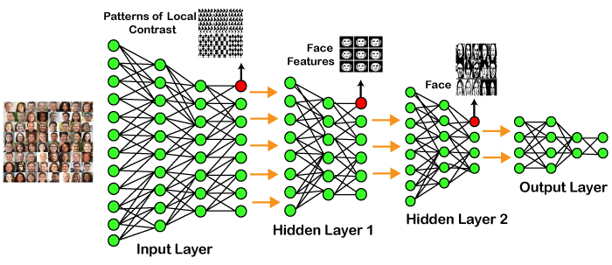
In the example given above, we provide the raw data of images to the first layer of the input layer. After then, these input layer will determine the patterns of local contrast that means it will differentiate on the basis of colors, luminosity, etc. Then the 1st hidden layer will determine the face feature, i.e., it will fixate on eyes, nose, and lips, etc. And then, it will fixate those face features on the correct face template. So, in the 2nd hidden layer, it will actually determine the correct face here as it can be seen in the above image, after which it will be sent to the output layer. Likewise, more hidden layers can be added to solve more complex problems, for example, if you want to find out a particular kind of face having large or light complexions. So, as and when the hidden layers increase, we are able to solve complex problems.
ARCHITECTURES
Deep Neural Networks
It is a neural network that incorporates the complexity of a certain level, which means several numbers of hidden layers are encompassed in between the input and output layers. They are highly proficient on model and process non-linear associations.
Deep Belief Networks
A deep belief network is a class of Deep Neural Network that comprises of multi-layer belief networks.
Steps to perform DBN:
- With the help of the Contrastive Divergence algorithm, a layer of features is learned from perceptible units.
- Next, the formerly trained features are treated as visible units, which perform learning of features.
- Lastly, when the learning of the final hidden layer is accomplished, then the whole DBN is trained.
RECURRENT NEURAL NETWORKS
It permits parallel as well as sequential computation, and it is exactly similar to that of the human brain (large feedback network of connected neurons). Since they are capable enough to reminisce all of the imperative things related to the input they have received, so they are more precise.
TYPES OF DEEP LEARNING NETWORKS
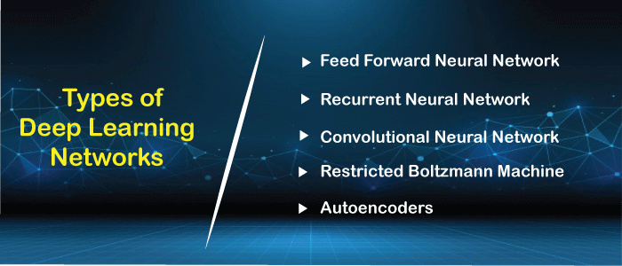
1. Feed Forward Neural Network
A feed-forward neural network is none other than an Artificial Neural Network, which ensures that the nodes do not form a cycle. In this kind of neural network, all the perceptrons are organized within layers, such that the input layer takes the input, and the output layer generates the output. Since the hidden layers do not link with the outside world, it is named as hidden layers. Each of the perceptrons contained in one single layer is associated with each node in the subsequent layer. It can be concluded that all of the nodes are fully connected. It does not contain any visible or invisible connection between the nodes in the same layer. There are no back-loops in the feed-forward network. To minimize the prediction error, the backpropagation algorithm can be used to update the weight values.
Applications:
- Data Compression
- Pattern Recognition
- Computer Vision
- Sonar Target Recognition
- Speech Recognition
- Handwritten Characters Recognition
2. Recurrent Neural Network
Recurrent neural networks are yet another variation of feed-forward networks. Here each of the neurons present in the hidden layers receives an input with a specific delay in time. The Recurrent neural network mainly accesses the preceding info of existing iterations. For example, to guess the succeeding word in any sentence, one must have knowledge about the words that were previously used. It not only processes the inputs but also shares the length as well as weights crossways time. It does not let the size of the model to increase with the increase in the input size. However, the only problem with this recurrent neural network is that it has slow computational speed as well as it does not contemplate any future input for the current state. It has a problem with reminiscing prior information.
Applications:
- Machine Translation
- Robot Control
- Time Series Prediction
- Speech Recognition
- Speech Synthesis
- Time Series Anomaly Detection
- Rhythm Learning
- Music Composition
3. Convolutional Neural Network
Convolutional Neural Networks are a special kind of neural network mainly used for image classification, clustering of images and object recognition. DNNs enable unsupervised construction of hierarchical image representations. To achieve the best accuracy, deep convolutional neural networks are preferred more than any other neural network.
Applications:
- Identify Faces, Street Signs, Tumors.
- Image Recognition.
- Video Analysis.
- NLP.
- Anomaly Detection.
- Drug Discovery.
- Checkers Game.
- Time Series Forecasting.
4. Restricted Boltzmann Machine
RBMs are yet another variant of Boltzmann Machines. Here the neurons present in the input layer and the hidden layer encompasses symmetric connections amid them. However, there is no internal association within the respective layer. But in contrast to RBM, Boltzmann machines do encompass internal connections inside the hidden layer. These restrictions in BMs helps the model to train efficiently.
Applications:
- Filtering.
- Feature Learning.
- Classification.
- Risk Detection.
- Business and Economic analysis.
5. Autoencoders
An autoencoder neural network is another kind of unsupervised machine learning algorithm. Here the number of hidden cells is merely small than that of the input cells. But the number of input cells is equivalent to the number of output cells. An autoencoder network is trained to display the output similar to the fed input to force AEs to find common patterns and generalize the data. The autoencoders are mainly used for the smaller representation of the input. It helps in the reconstruction of the original data from compressed data. This algorithm is comparatively simple as it only necessitates the output identical to the input.
- Encoder: Convert input data in lower dimensions.
- Decoder: Reconstruct the compressed data.
Applications:
- Classification.
- Clustering.
- Feature Compression.
Deep learning applications
- Self-DrivingCars
In self-driven cars, it is able to capture the images around it by processing a huge amount of data, and then it will decide which actions should be incorporated to take a left or right or should it stop. So, accordingly, it will decide what actions it should take, which will further reduce the accidents that happen every year.
- VoiceControlledAssistance
When we talk about voice control assistance, then Siri is the one thing that comes into our mind. So, you can tell Siri whatever you want it to do it for you, and it will search it for you and display it for you.
- Automatic Image Caption Generation
Whatever image that you upload, the algorithm will work in such a way that it will generate caption accordingly. If you say blue colored eye, it will display a blue-colored eye with a caption at the bottom of the image.
- Automatic Machine Translation
With the help of automatic machine translation, we are able to convert one language into another with the help of deep learning.
Limitations
- It only learns through the observations.
- It comprises of biases issues.
Advantages
- It lessens the need for feature engineering.
- It eradicates all those costs that are needless.
- It easily identifies difficult defects.
- It results in the best-in-class performance on problems.
Disadvantages
- It requires an ample amount of data.
- It is quite expensive to train.
- It does not have strong theoretical groundwork

CNN
A Convolutional Neural Network (CNN) is a type of Deep Learning neural network architecture commonly used in Computer Vision. Computer vision is a field of Artificial Intelligence that enables a computer to understand and interpret the image or visual data. When it comes to Machine Learning, Artificial Neural Networks perform really well. Neural Networks are used in various datasets like images, audio, and text. Different types of Neural Networks are used for different purposes, for example for predicting the sequence of words we use Recurrent Neural Networks more precisely an LSTM, similarly for image classification we use Convolution Neural networks. In this blog, we are going to build a basic building block for CNN.
In a regular Neural Network there are three types of layers:
Input Layers: It’s the layer in which we give input to our model. The number of neurons in this layer is equal to the total number of features in our data (number of pixels in the case of an image).
Hidden Layer: The input from the Input layer is then fed into the hidden layer. There can be many hidden layers depending on our model and data size. Each hidden layer can have different numbers of neurons which are generally greater than the number of features. The output from each layer is computed by matrix multiplication of the output of the previous layer with learnable weights of that layer and then by the addition of learnable biases followed by activation function which makes the network nonlinear.
Output Layer: The output from the hidden layer is then fed into a logistic function like sigmoid or softmax which converts the output of each class into the probability score of each class.
The data is fed into the model and output from each layer is obtained from the above step is called feedforward, we then calculate the error using an error function, some common error functions are cross-entropy, square loss error, etc. The error function measures how well the network is performing. After that, we backpropagate into the model by calculating the derivatives. This step is called Backpropagation which basically is used to minimize the loss.
Convolution Neural Network Convolutional Neural Network (CNN) is the extended version of artificial neural networks (ANN) which is predominantly used to extract the feature from the grid-like matrix dataset. For example visual datasets like images or videos where data patterns play an extensive role.

CNN architecture
Convolutional Neural Network consists of multiple layers like the input layer, Convolutional layer, Pooling layer, and fully connected layers.
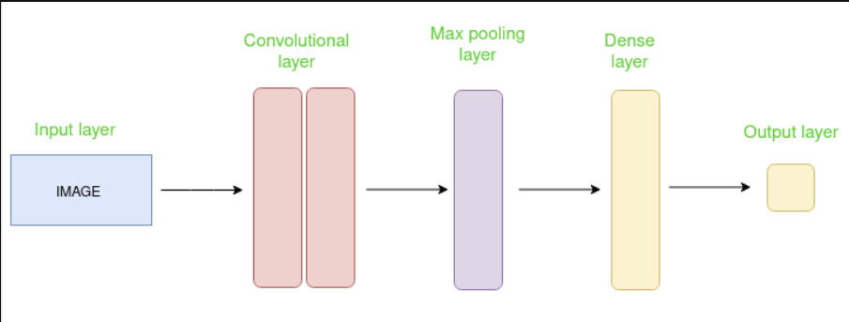

The Convolutional layer applies filters to the input image to extract features, the Pooling layer downsamples the image to reduce computation, and the fully connected layer makes the final prediction. The network learns the optimal filters through backpropagation and gradient descent.
How Convolutional Layers works
Convolution Neural Networks or covnets are neural networks that share their parameters. Imagine you have an image. It can be represented as a cuboid having its length, width (dimension of the image), and height (i.e the channel as images generally have red, green, and blue channels).
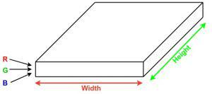
Now imagine taking a small patch of this image and running a small neural network, called a filter or kernel on it, with say, K outputs and representing them vertically. Now slide that neural network across the whole image, as a result, we will get another image with different widths, heights, and depths. Instead of just R, G, and B channels now we have more channels but lesser width and height. This operation is called Convolution. If the patch size is the same as that of the image it will be a regular neural network. Because of this small patch, we have fewer weights.
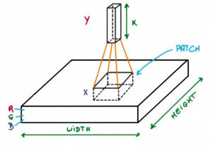
Now let’s talk about a bit of mathematics that is involved in the whole convolution process.

Convolution layers consist of a set of learnable filters (or kernels) having small widths and heights and the same depth as that of input volume (3 if the input layer is image input).
For example, if we have to run convolution on an image with dimensions 34x34x3. The possible size of filters can be axax3, where ‘a’ can be anything like 3, 5, or 7 but smaller as compared to the image dimension.
During the forward pass, we slide each filter across the whole input volume step by step where each step is called stride (which can have a value of 2, 3, or even 4 for high-dimensional images) and compute the dot product between the kernel weights and patch from input volume.
As we slide our filters we’ll get a 2-D output for each filter and we’ll stack them together as a result, we’ll get output volume having a depth equal to the number of filters. The network will learn all the filters.
Layers used to build ConvNets
A complete Convolution Neural Networks architecture is also known as covnets. A covnets is a sequence of layers, and every layer transforms one volume to another through a differentiable function.
Types of layers: datasets
Let’s take an example by running a covnets on of image of dimension 32 x 32 x 3.

Input Layers: It’s the layer in which we give input to our model. In CNN, Generally, the input will be an image or a sequence of images. This layer holds the raw input of the image with width 32, height 32, and depth 3.
Convolutional Layers: This is the layer, which is used to extract the feature from the input dataset. It applies a set of learnable filters known as the kernels to the input images. The filters/kernels are smaller matrices usually 2×2, 3×3, or 5×5 shape. it slides over the input image data and computes the dot product between kernel weight and the corresponding input image patch. The output of this layer is referred ad feature maps. Suppose we use a total of 12 filters for this layer we’ll get an output volume of dimension 32 x 32 x 12.
Activation Layer: By adding an activation function to the output of the preceding layer, activation layers add nonlinearity to the network. it will apply an element-wise activation function to the output of the convolution layer. Some common activation functions are RELU: max(0, x), Tanh, Leaky RELU, etc. The volume remains unchanged hence output volume will have dimensions 32 x 32 x 12.
Pooling layer: This layer is periodically inserted in the covnets and its main function is to reduce the size of volume which makes the computation fast reduces memory and also prevents overfitting. Two common types of pooling layers are max pooling and average pooling. If we use a max pool with 2 x 2 filters and stride 2, the resultant volume will be of dimension 16x16x12.
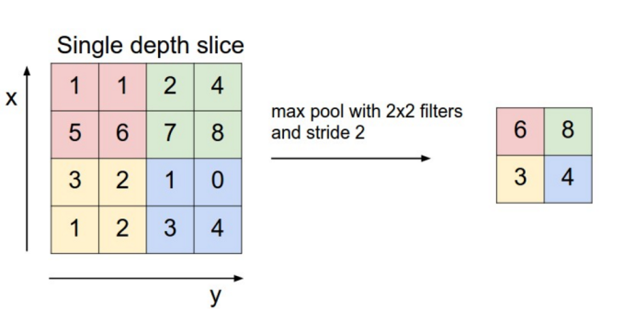
Flattening: The resulting feature maps are flattened into a one-dimensional vector after the convolution and pooling layers so they can be passed into a completely linked layer for categorization or regression.
Fully Connected Layers: It takes the input from the previous layer and computes the final classification or regression task.
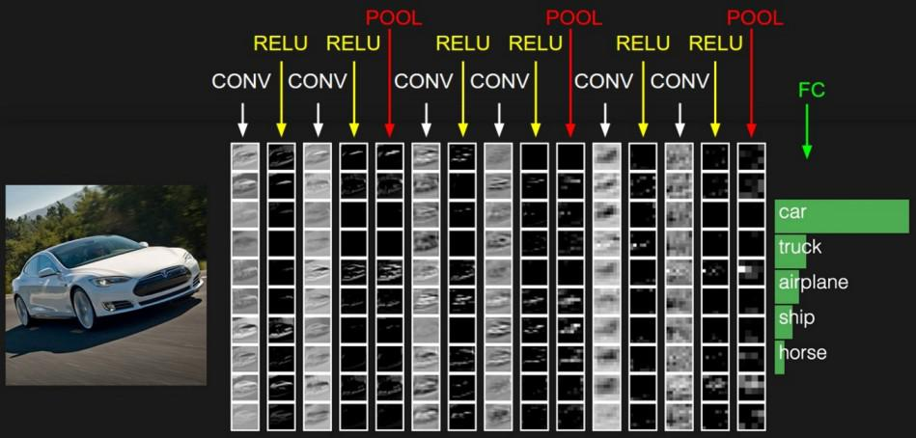
Output Layer: The output from the fully connected layers is then fed into a logistic function for classification tasks like sigmoid or softmax which converts the output of each class into the probability score of each class.
3.3 MATPLOTLIB
Matplotlib is a Python 2D plotting library which produces publication quality figures in a variety of hardcopy formats and interactive environments across platforms. Matplotlib can be used in Python scripts, the Python and IPython shells, the Jupyter notebook, web application servers, and four graphical user interface toolkits. It provides a variety of functions to visualize data and create static, animated, and interactive plots. Matplotlib is widely used for tasks ranging from simple line plots to complex visualizations.

The Visualization Design using matplotlib
- Bar Graph
- Pie Chart
- Box Plot
- Histogram
- Line Chart and Subplots
- Scatter Plot

3.4 BAR GRAPH
Bar graphs are best used when we need to compare the quantity of categorical values within the same category. Bar graphs should not be used for continuous values.
Bar graph is generated using plt.bar() in matplotlib
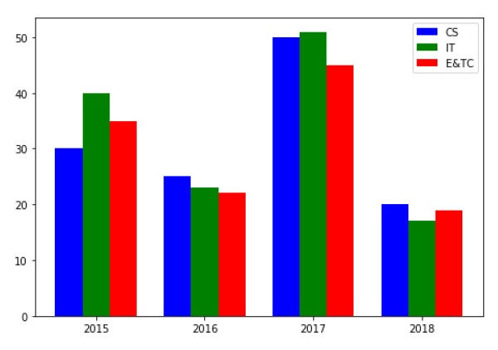
Figure 3.3. Bar Graph

3.5 PIE CHART USING MATPLOTLIB
A pie chart is suitable to show the proportional distribution of items within the same category.plt.pie() is used to draw the pie chart and adjust its parameters to make it more appealing.
A pie chart is rendered useless when there are a lot of items within a category. This will decrease the size of each slice and there will be no distinction between the items.
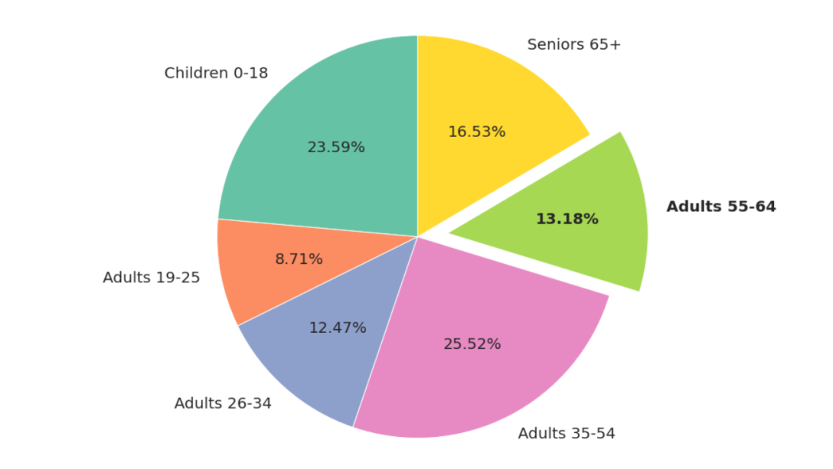
Figure 3.4. Pie Chart

3.6 BOX PLOT USING MATPLOTLIB
Box plot gives statistical information about the distribution of numeric data divided into different groups. It is useful for detecting outliers within each group. The lower, middle and upper part of the box represents the 25th, 50th, and 75th percentile values respectively. Box plot does not show the distribution of data points within each group.
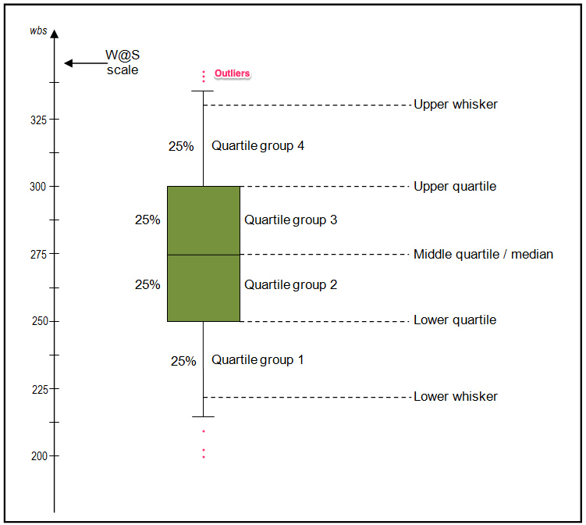
Figure 3.5. Box Plot

3.7 HISTOGRAM USING MATPLOTLIB
A histogram shows the distribution of numeric data through a continuous interval by segmenting data into different bins. Useful for inspecting skewness in the data. It is easy to confuse histograms with bar plots. But remember, histograms are used with continuous data whereas bar plots are used with categorical data.
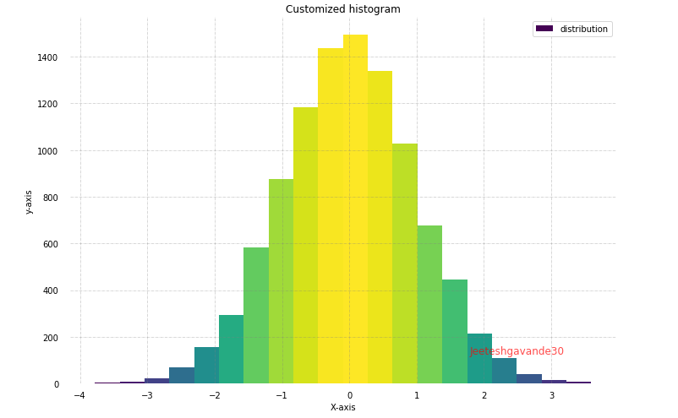
Figure 3.6. Histogram

3.8 LINE PLOT AND SUBPLOTS USING MATPLOTLIB
A line plot is useful for visualizing the trend in a numerical value over a continuous time interval. Matplotlib subplots makes it easy to view and compare different plots in the same figure. The plt.subplots() figure returns the figure and axes. You can provide as an input to the function how you want to display the axes within the figure. These will be adjusted using the nrows and ncols parameters. You can even adjust the size of the figure using the figsize parameter.
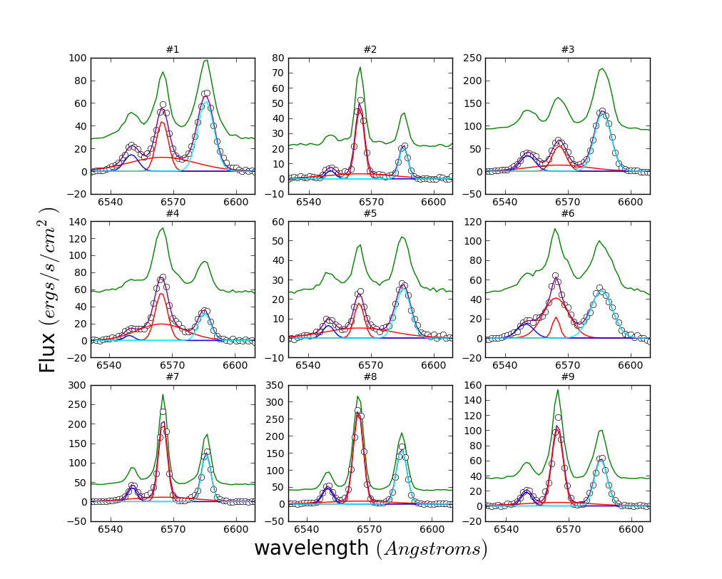
Figure 3.7. Subplot

3.9 SCATTER PLOT USING MATPLOTLIB
Scatter plots are useful for showing the relationship between two variables. Any correlation between variables or outliers in the data can be easily spotted using scatter plots.
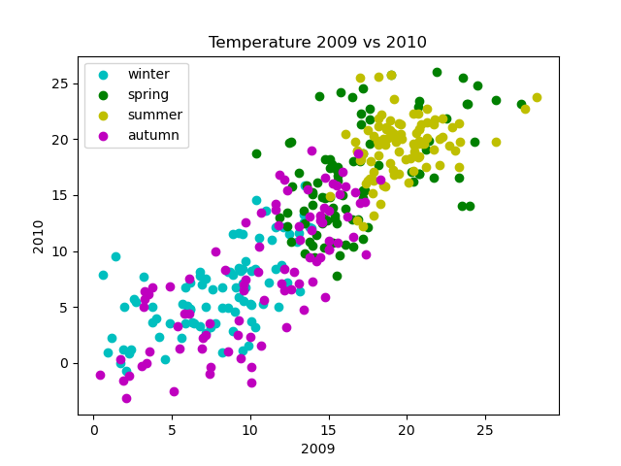
Figure 3.8. Scatter Plot
3.10 SEABORN
Seaborn is a statistical data visualization library based on Matplotlib. Seaborn is a powerful and flexible data visualization library in Python that offers an easy-to-use interface for creating informative and aesthetically pleasing statistical graphics. It provides a range of tools for visualizing data, including advanced statistical analysis, and makes it easy to create complex multi-plot visualizations..Seaborn's key benefit lies in its capability to generate attractive plots with minimal coding efforts. It provides a range of default themes and color palettes, which you can easily customize to suit your preferences. Additionally, Seaborn offers a range of built-in statistical functions, allowing users to easily perform complex statistical analysis with their visualizations. Another notable feature of Seaborn is its ability to create complex multi-plot visualizations. With Seaborn, users can create grids of plots that allow for easy comparison between multiple variables or subsets of data. This makes it an ideal tool for exploratory data analysis and presentation.
3.11 PLOT TYPES IN SEABORN
- LINE PLOT: Line plots are used to visualize trends in data over time or other continuous variables. In a line plot, each data point is connected by a line, creating a smooth curve. In Seaborn, line plots can be created using the lineplot() function.
- HISTOGRAM: Histograms visualize the distribution of a continuous variable. In a histogram, the data is divided into bins and the height of each bin represents the frequency or count of data points within that bin. In Seaborn, histograms can be created using the histplot() function.
- BOX PLOT: Box plots are a type of visualization that shows the distribution of a dataset. They are commonly used to compare the distribution of one or more variables across different categories.
- VIOLIN PLOT: A violin plot is a type of data visualization that combines aspects of both box plots and density plots. It displays a density estimate of the data, usually smoothed by a kernel density estimator, along with the interquartile range (IQR) and median in a box plot-like form. The width of the violin represents the density estimate, with wider parts indicating higher density, and the IQR and median are shown as a white dot and line within the violin.
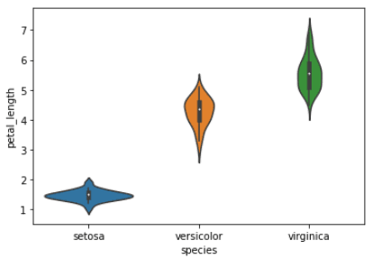
Figure 3.9. Violin Plot
- HEATMAP. A heatmap is a graphical representation of data that uses colors to depict the value of a variable in a two-dimensional space. Heatmaps are commonly used to visualize the correlation between different variables in a dataset.
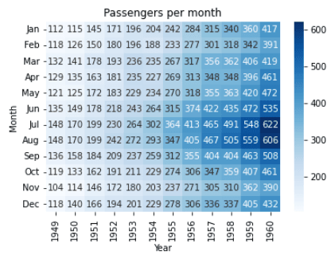
Figure 3.10. Heat Map
- PAIRPLOT: Pair plots are a type of visualization in which multiple pairwise scatter plots are displayed in a matrix format. Each scatter plot shows the relationship between two variables, while the diagonal plots show the distribution of the individual variables.
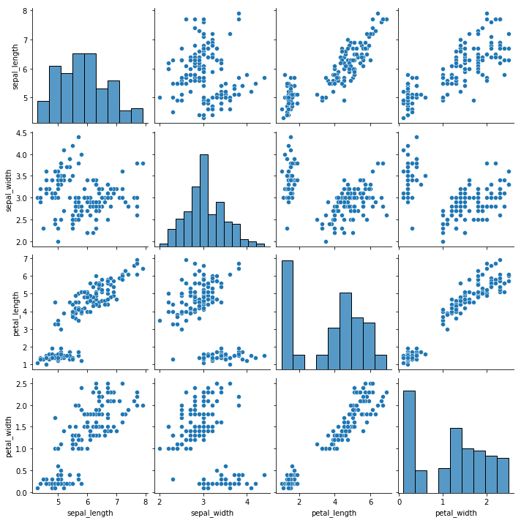
Figure 3.11. Pair Plot

CHAPTER 4:
TOOLS/ HARDWARE & SOFTWARE REQUIREMENTS
HTML and JavaScript: The HTML structure defines the login page content, layout, and interactive elements. JavaScript provides dynamic functionality, including interactions and input validation reCAPTCHA:
This page references Google reCAPTCHA (https://www.gstatic.com/recaptcha) to prevent automated bots from accessing the login system, providing an added layer of security. Wordtune: A script for Wordtune is installed on the page, which might assist in text-related enhancements. Tailwind CSS: Tailwind CSS framework is applied for utility-based styling, allowing modular design and rapid customization.
Font Awesome Icons: Several icon classes (svg-inline--fa) suggest the use of Font Awesome for icons, aiding in visual cues for users on the login page.
H/W SYSTEM CONFIGURATION:-
➢ Processor - Pentium –IV
➢ RAM - 4 GB (min)
➢ Hard Disk - 20 GB
➢ Key Board - Standard Windows Keyboard
➢ Mouse - Two or Three Button Mouse
➢ Monitor - SVGA
SOFTWARE REQUIREMENTS:
- Operating system : Windows 7 Ultimate.
- Coding Language : Python.
- Front-End : Python.
- Back-End : Django-ORM
- Designing : Html, css, javascript.
- Data Base : MySQL (WAMP Server).
CHAPTER-5
IMPLEMENTATION
SYSTEM ARCHITECTURE
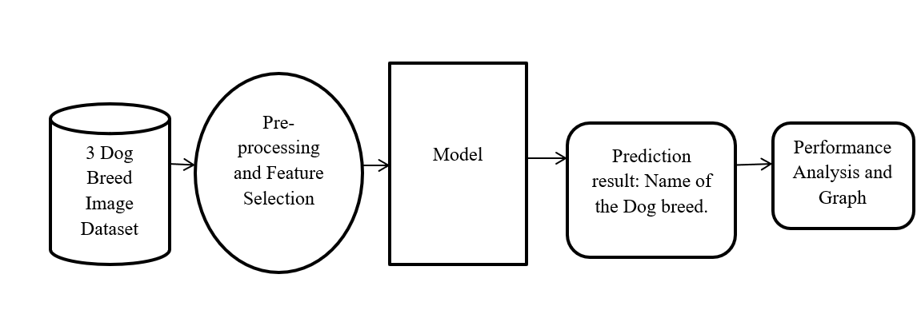
UML DIAGRAMS
UML stands for Unified Modeling Language. UML is a standardized general-purpose modeling language in the field of object-oriented software engineering. The standard is managed, and was created by, the Object Management Group.
The goal is for UML to become a common language for creating models of object oriented computer software. In its current form UML is comprised of two major components: a Meta-model and a notation. In the future, some form of method or process may also be added to; or associated with, UML.
The Unified Modeling Language is a standard language for specifying, Visualization, Constructing and documenting the artifacts of software system, as well as for business modeling and other non-software systems.
The UML represents a collection of best engineering practices that have proven successful in the modeling of large and complex systems.
The UML is a very important part of developing objects oriented software and the software development process. The UML uses mostly graphical notations to express the design of software projects.

GOALS:
The Primary goals in the design of the UML are as follows:
- Provide users a ready-to-use, expressive visual modeling Language so that they can develop and exchange meaningful models.
- Provide extendibility and specialization mechanisms to extend the core concepts.
- Be independent of particular programming languages and development process.
- Provide a formal basis for understanding the modeling language.
- Encourage the growth of OO tools market.
- Support higher level development concepts such as collaborations, frameworks, patterns and components.
- Integrate best practices.

USE CASE DIAGRAM:
A use case diagram in the Unified Modeling Language (UML) is a type of behavioral diagram defined by and created from a Use-case analysis. Its purpose is to present a graphical overview of the functionality provided by a system in terms of actors, their goals (represented as use cases), and any dependencies between those use cases. The main purpose of a use case diagram is to show what system functions are performed for which actor. Roles of the actors in the system can be depicted.
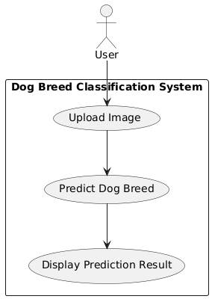
CLASS DIAGRAM:
In software engineering, a class diagram in the Unified Modeling Language (UML) is a type of static structure diagram that describes the structure of a system by showing the system's classes, their attributes, operations (or methods), and the relationships among the classes. It explains which class contains information.
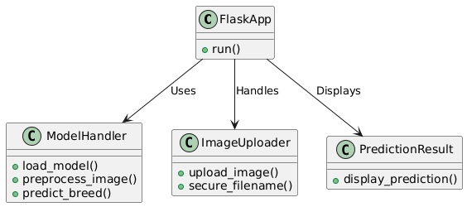

SEQUENCE DIAGRAM:
A sequence diagram in Unified Modeling Language (UML) is a kind of interaction diagram that shows how processes operate with one another and in what order. It is a construct of a Message Sequence Chart. Sequence diagrams are sometimes called event diagrams, event scenarios, and timing diagrams
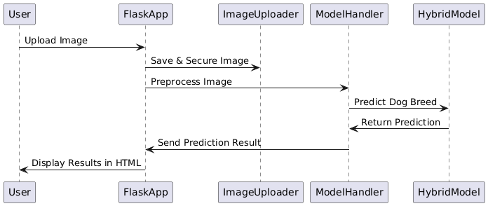
COLLABORATION DIAGRAM
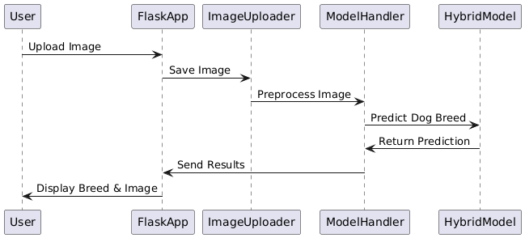

COMPONENT DIAGRAM
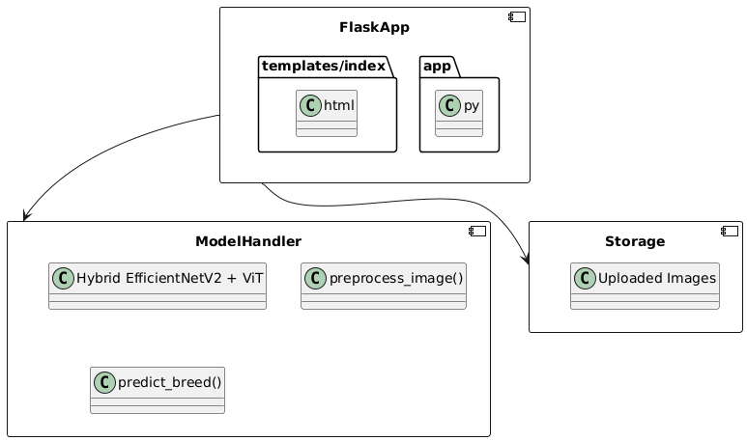

DEPLOYMENT DIAGRAM
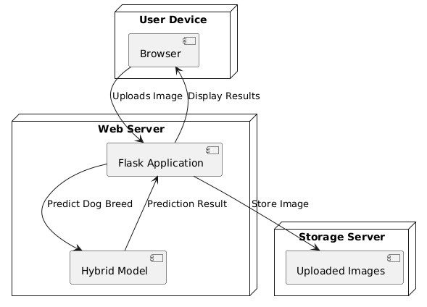

DATA FLOW DIAGRAM:

- The DFD is also called as bubble chart. It is a simple graphical formalism that can be used to represent a system in terms of input data to the system, various processing carried out on this data, and the output data is generated by this system.
- The data flow diagram (DFD) is one of the most important modeling tools. It is used to model the system components. These components are the system process, the data used by the process, an external entity that interacts with the system and the information flows in the system.
- DFD shows how the information moves through the system and how it is modified by a series of transformations. It is a graphical technique that depicts information flow and the transformations that are applied as data moves from input to output.
- DFD is also known as bubble chart. A DFD may be used to represent a system at any level of abstraction. DFD may be partitioned into levels that represent increasing information flow and functional detail.

DFD Level 0
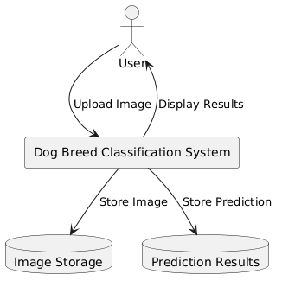
DFD Level 1
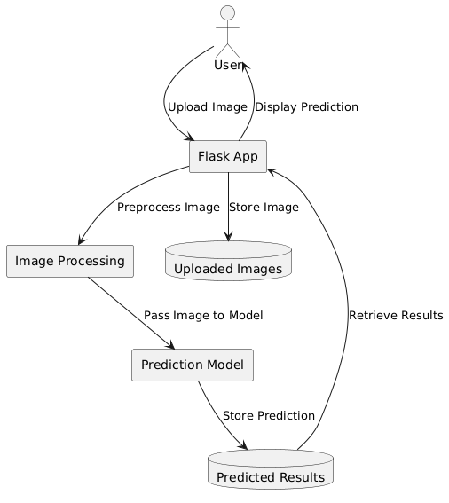

CHAPTER-6
SAMPLE CODE
from flask import Flask, render_template, request
import tensorflow as tf
import numpy as np
import os
import tensorflow_hub as hub
from tensorflow.keras.preprocessing import image
from tensorflow.keras.layers import Lambda
from werkzeug.utils import secure_filename

app = Flask(__name__)
app.config['UPLOAD_FOLDER'] = 'static/uploads'
os.makedirs(app.config['UPLOAD_FOLDER'], exist_ok=True)

# Load the trained model
MODEL_PATH = "model/hybrid_dog_breed_classifier.keras"
model = tf.keras.models.load_model(
MODEL_PATH,
custom_objects={"vit_lambda": Lambda(lambda x: hub.KerasLayer("https://tfhub.dev/sayakpaul/vit_b16_fe/1")(x))}
)

# Define Class Labels (120 Breeds)
CLASS_NAMES = sorted(os.listdir("model/dataset/train"))

# Function to preprocess the image
def preprocess_image(img_path):
img = image.load_img(img_path, target_size=(224, 224))
img_array = image.img_to_array(img)
img_array = np.expand_dims(img_array, axis=0)
img_array /= 255.0 # Normalize (0-1 range)
return img_array

# Function to predict breed
def predict_breed(img_path):
img_array = preprocess_image(img_path)
predictions = model.predict(img_array)
predicted_class_index = np.argmax(predictions[0])
predicted_breed = CLASS_NAMES[predicted_class_index]
confidence = np.max(predictions[0]) * 100
return predicted_breed, confidence

@app.route('/', methods=['GET', 'POST'])
def home():
if request.method == 'POST':
if 'file' not in request.files:
return render_template('index.html', error="No file uploaded")
file = request.files['file']
if file.filename == '':
return render_template('index.html', error="No file selected")

filename = secure_filename(file.filename)
filepath = os.path.join(app.config['UPLOAD_FOLDER'], filename)
file.save(filepath)

breed, confidence = predict_breed(filepath)

return render_template('index.html', filename=filename, breed=breed, confidence=confidence)
return render_template('index.html')

if __name__ == '__main__':
app.run(debug=True)

SCREEN SHOTS
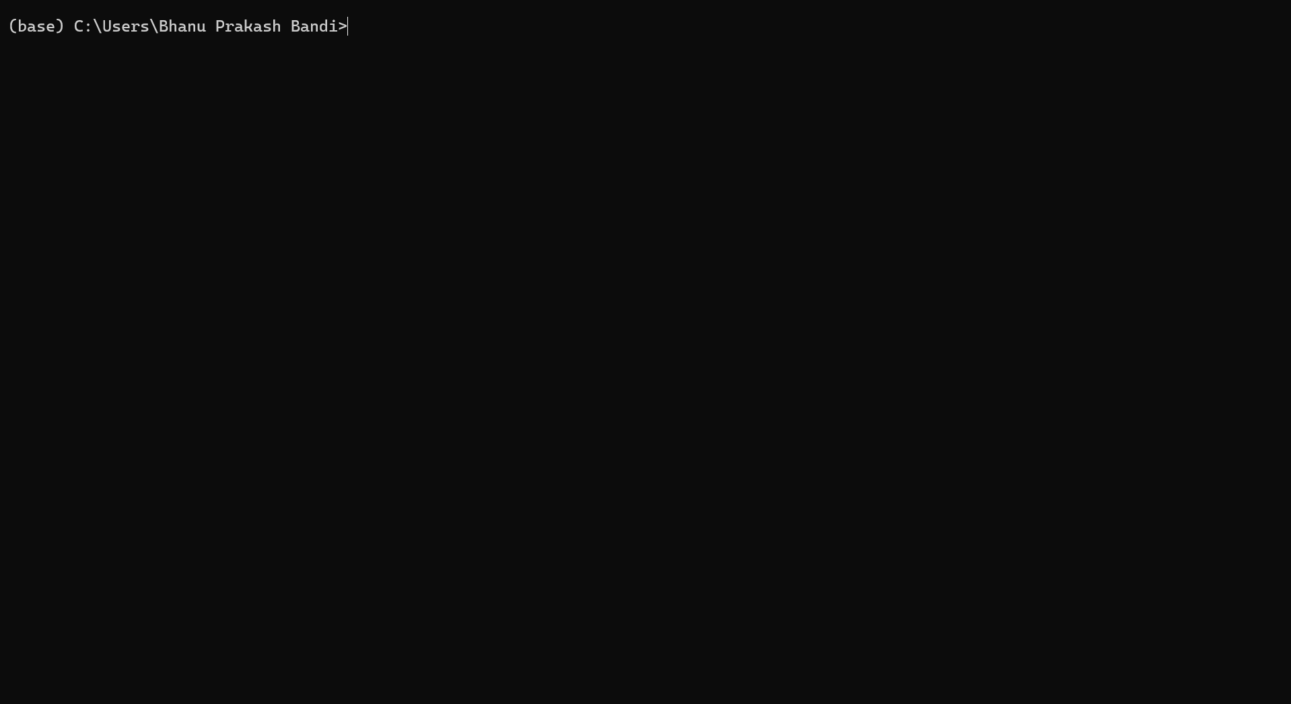
Fig: Anaconda navigator
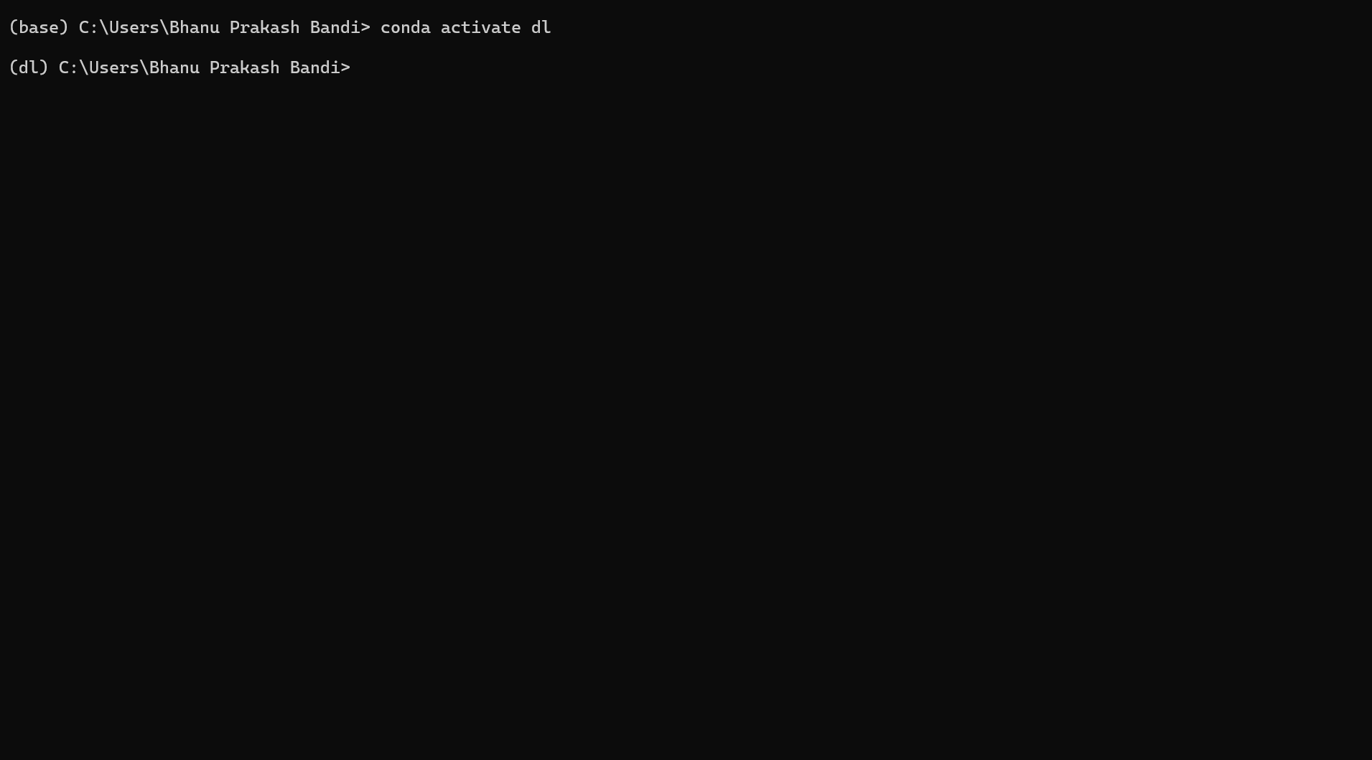
Fig: Creating an Environment
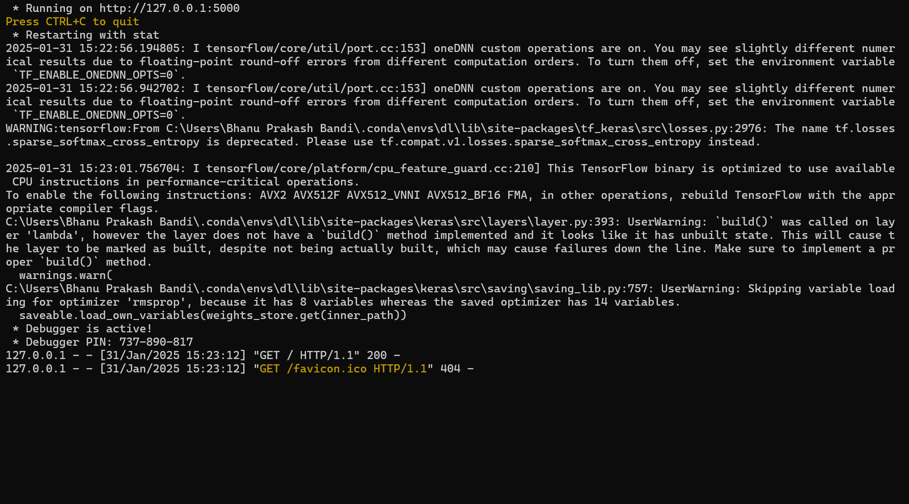
Fig: Executing The Project
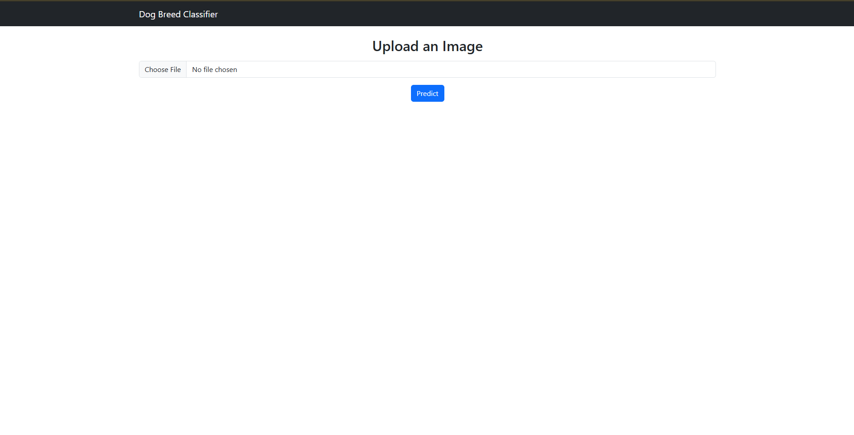
Fig: Login Page
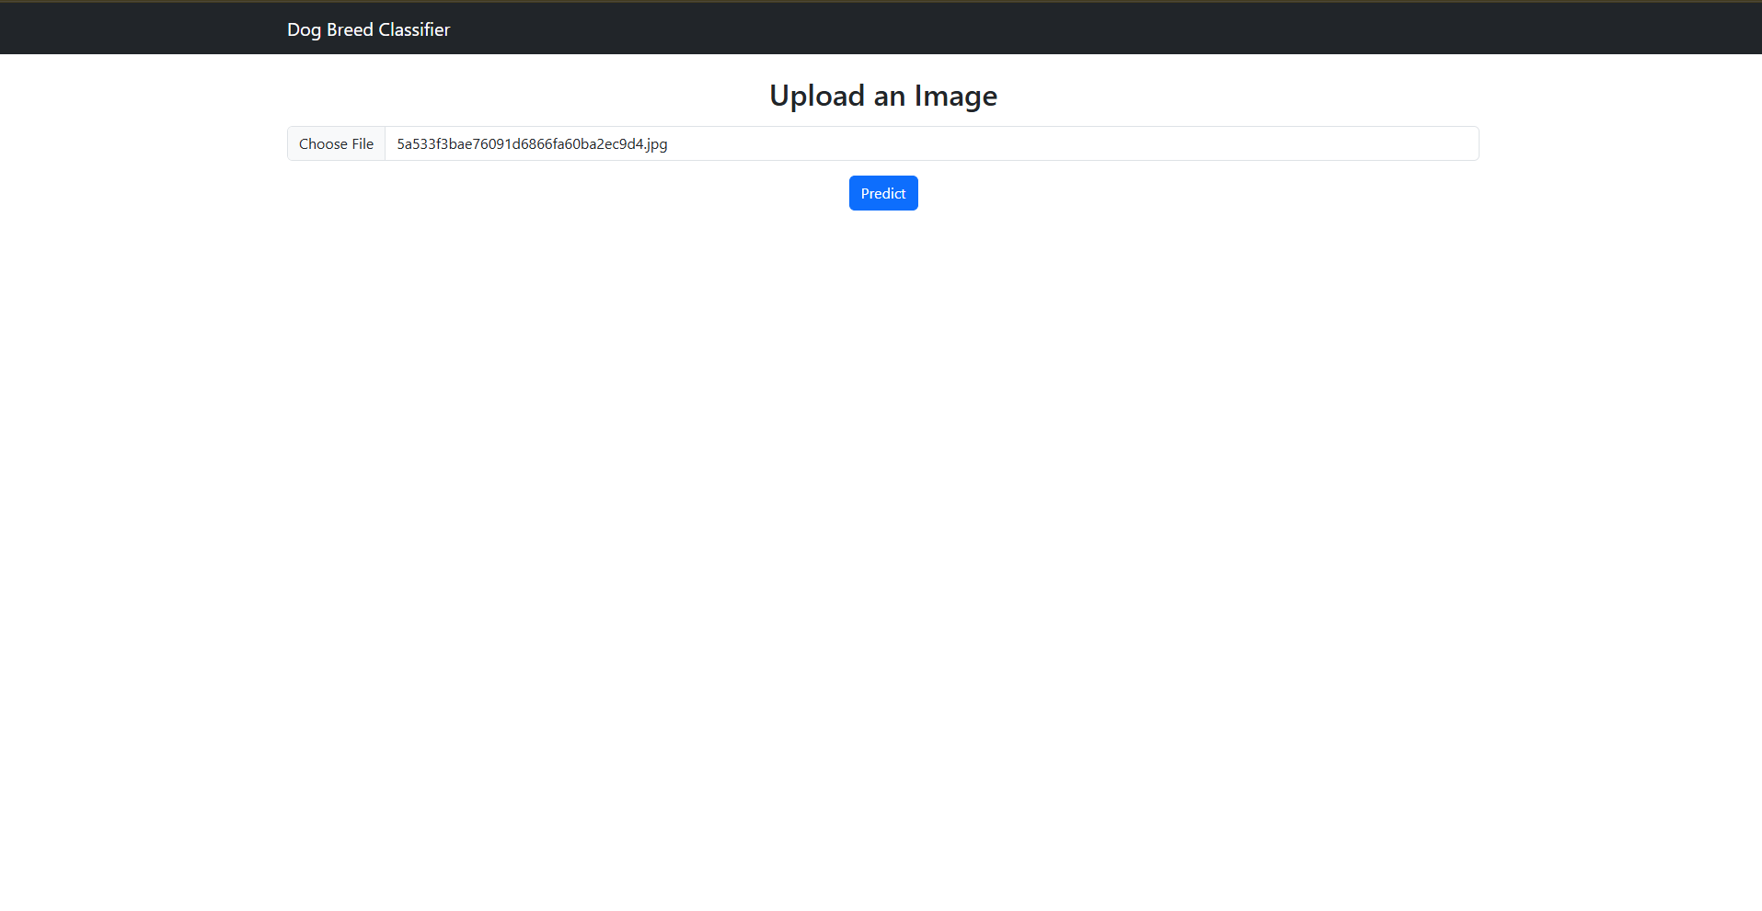
Fig: Uploading The Dog To Detect breed
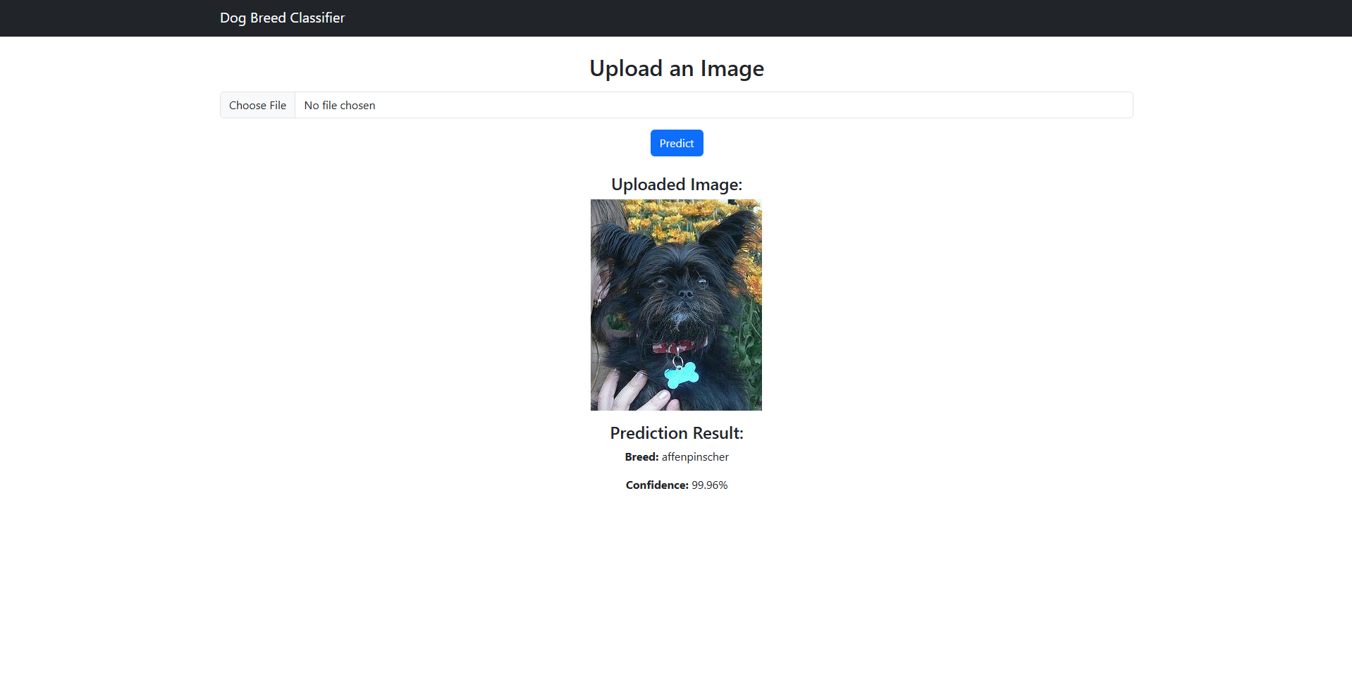
Fig: Displaying Result

CONCLUSION AND DISCUSSION
Considering the large number of breeds in this fine-grained classification problem, we view our overall findings as successful. Given the high variability both between and within the 120 different breeds included in the dataset, we successfully predict the right breed over 92.4% of the time in a single guess, a result that very few models could match. The training accuracy which we got is 98.4% and the validation accuracy which we got is 92.4% for Hybrid (Inception-v3 + Xception). The training accuracy value for VGG19 algorithm which we got is 85% and the validation accuracy which we got is 55%. The proposed algorithms give a validation accuracy score of 91.9% for Xception, 55% for VGG19, 83.47% for NASNetMobile, 89.05% for EfficientNetV2M, 87.38% for ResNet152V2, 92.4% for Hybrid of Inceptionv3 & Xception, and 89.00% for Hybrid of EfficientNetV2M, NASNetMobile, Inception & Xception. Among these algorithms, Hybrid of Inception-v3 & Xception gives the highest accuracy of 92.4%. Other machine learning models, neural networks, and deep learning models should all be further investigated in future work on canine breed prediction. This is an approach that has promise for upcoming tasks given the success of our hybrid detection network. Due to time and CPU limitations, it was found difficult to conduct many iterations of our technique using Neural Networks because training each and every layer of the model is a very time-consuming process. So, in order to train the complete model and increase accuracy, we anticipate receiving better GPU and equipment. We advise further research into neural networks for key point detection, particularly by training networks with different architectures and batch iterators to see what strategies might be more effective. In the end, neural network architectures take a long period to train and iterate, which should be taken into account for future work. However, compared to more conventional methods, neural networks are powerful classifiers and will improve prediction accuracy.

REFERENCES
[1] C.Wang, J.Wang, Q. Du, and X. Yang, ‘‘Dog breed classification based on deep learning,’’ in Proc. 13th Int. Symp. Comput. Intell. Design (ISCID), Dec. 2020, pp. 209–212, doi: 10.1109/ISCID51228.2020.00053.
[2] X. Tu, K. Lai, and S. Yanushkevich, ‘‘Transfer learning on convolutional neural networks for dog identification,’’ in Proc. IEEE 9th Int. Conf. Softw. Eng. Service Sci. (ICSESS), Nov. 2018, pp. 357–360, doi: 10.1109/ICSESS.2018.8663718.
[3] Z. Ráduly, C. Sulyok, Z. Vadászi, and A. Zölde, ‘‘Dog breed identification using deep learning,’’ in Proc. IEEE 16th Int. Symp. Intell. Syst. Informat. (SISY), Sep. 2018, pp. 271–276, doi: 10.1109/sisy.2018.8524715.
[4] A. Varshney, A. Katiyar, A. K. Singh, and S. S. Chauhan, ‘‘Dog breed classification using deep learning,’’ in Proc. Int. Conf. Intell. Technol. (CONIT), Jun. 2021, pp. 1–5, doi: 10.1109/conit51480.2021.9498338.
[5] R. O. Sinnott, F. Wu, and W. Chen, ‘‘A mobile application for dog breed detection and recognition based on deep learning,’’ in Proc. IEEE/ACM 5th Int. Conf. Big Data Comput. Appl. Technol. (BDCAT), Dec. 2018, pp. 87–96, doi: 10.1109/BDCAT.2018.00019.
[6] M.V. S. Rishita and T. A. Harris, ‘‘Dog breed classifier using convolutional neural networks,’’ in Proc. Int. Conf. Netw., Embedded Wireless Syst. (ICNEWS), Dec. 2018, pp. 1–7, doi: 10.1109/ICNEWS.2018.8903980.
[7] A. Ayanzadeh and S. Vahidnia, ‘‘Modified deep neural networks for dog breeds identification,’’ 2018, Art. no. 2018120232, doi: 10.20944/preprints201812.0232.v1.
[8] A. Sharma, A. Sahoo, M. Azhagiri, and D. Dutta, ‘‘Recognition of dog breeds using convolutional neural network and visual geometry group,’’ Int. J. Eng. Adv. Technol., vol. 9, no. 1, pp. 3898–3902, Oct. 2019.
[9] B. V. Kumar and K. Bhavya, ‘‘Dog breed identification with fine tuning of pre-trained models,’’ Int. J. Recent Technol. Eng. (IJRTE), vol. 8, nos. 2– 11, pp. 3677–3680, Sep. 2019.
[10] P. Borwarnginn, K. Thongkanchorn, S. Kanchanapreechakorn, and W. Kusakunniran, ‘‘Breakthrough conventional based approach for dog breed classification using CNN with transfer learning,’’ in Proc. 11th Int. Conf. Inf. Technol. Electr. Eng. (ICITEE), Oct. 2019, pp. 1–5, doi: 10.1109/iciteed.2019.8929955.

